**ELEMENTARY BOOK – UNITS 1 – 12 REVISION TEST**

1. **Present Simple or be?**

I ___________ from Zlín. I ___________ tired, because I went to bed late.

My friend ___________ in the USA. Our dog ___________ 10 years old.

I ___________ gardening. My mom’s name ___________ Jana.

My classmates ___________ great. We ___________ a great teacher.

1. **What time is it?**

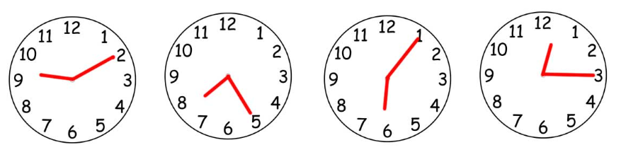

_________________ _________________ ____________________ _________________

1. **Noodles- days, months, seasons + prepositions of time**
2. Jezdíš vždy lyžovat v únoru?
3. Chodíš do kina v pátky?
4. Co obvykle děláš v létě?
5. Cítíš se víc unavený na podzim?
6. **There is/are + prepositions of place**

1. There _______ a cat _____________ the box.
2. There _______ a cat _____________ the box.
3. There _______ a cat _____________ the box.
4. There _______ cats ______________ the box.
5. **Can, could, was/were**
6. Umíš jezdit na kole?
7. Umí tvoji přátelé plavat rychle?
8. Uměl jsi číst, když ti bylo 5?
9. Uměl jsi řídit auto, když ti bylo 18?
10. **Past Simple – irregular verbs**

**buy go do Get make leave**

1. When was the last time you ________ to the cinema?
2. When was the last time you ________ housework?
3. When was the last time you ________ a new jacket?
4. When was the last time you ________ a bunch of flowers?
5. When was the last time you ________ work early?
6. When was the last time you ________ a cake?
7. **Comparatives and superlatives**
8. Is Zlín _________ than Prague? (safe)
9. What is _________ city in the Czech republic? (big)
10. Are you _________ than your classmates? (tall)
11. Who is _________ person in the world? (rich)

1. **Going to & infinitive of purpose**
2. Chystáš se k moři, aby ses opaloval/a?
3. Chystáš se pracovat tvrdě, abys dostal/a přidáno?
4. Chystáš se studovat angličtinu příští rok, aby ses naučil/a nová slovíčka?
5. Chystáš se navštívit Francii, abys viděl/a Eiffelovku?
6. **Directions**

Jdi rovně a potom zaboč doleva. ______________________________________________

Na kruhovém objezdu zaboč doprava. _____________________________________________

Jdi skrz park. _________________________________________________________________

1. **Present Continuous, clothes, appearances – describe these two people. What are they wearing? What do they look like?**

1. **Adjectives ed/ing**
2. I am very tir___. I didn’t sleep well last night.
3. My friend is really excit____ because she’s travelling to NY tomorrow.
4. Horror films can be frighten____.
5. My team lost again. I am really annoy____.
6. **Present Perfect**
7. My friend ________never __________ to the USA. (been)
8. I _______just __________ a ghost! (see)
9. My classmates ________already ____________ Present Perfect. (learn)
10. I ____________________ my homework yet. (not do)